24.13: a) 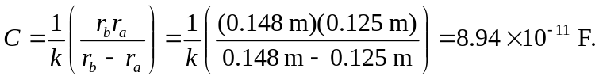
b) The electric field at a distance of 12.6 cm:
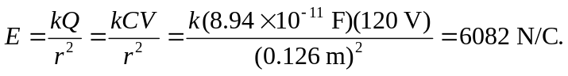
c) The electric field at a distance of 14.7 cm:
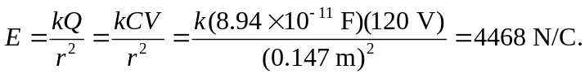
d) For a spherical capacitor, the electric field is not constant between the surfaces.

